

NCIA – National Cancer Imaging Archive

Software Design Description

Release 2.4 – Verify Submission



Document Change Record
Version Number | Date | Description
1.0 | 05/10/07 | Initial document

TABLE OF CONTENTS
1. Introduction 1
1.1 PROJECT BACKGROUND 1
1.2 SYSTEM OVERVIEW 1
2. System Architecture 2
3. configuration 3
3.1 CSM Configuration 3
3.2 NCIA.PROPERTIES 3
4. Sequence diagrams 4
4.1 Verify that submitted files were received 4
5. Components 5
5.1 USER INTERFACE 5
5.1.1 Search Page 5
5.1.2 Search Results 6
5.2 User interface Backing Beans 7
5.2.1 VerifySubmissionBean 7
5.2.2 SiteSubmissionReportDTO 8
5.2.3 SubmissionReportDateDTO 8
5.2.4 BeanManager 10
5.3 MIDDLE TIER 10
5.3.1 SiteCriteria 10
5.3.2 DateRangeCriteria 10
5.3.3 VerifySubmissionQuery 10
5.3.4 QuarantinedFileQuery 11
5.3.5 QueryType 11
5.3.6 QueryFactory 11
5.3.7 VerifySubmissionResultSet 11
5.3.8 QuarantinedFileResultSet 12
5.3.9 VerifySubmissionResultSetManager 12
5.3.10 VerifySubmissionQueryHandler 12
5.3.11 QuarantinedFileQueryHandler 13
5.4 UTILITIES 13
5.4.1 Utility class to handle quarantined files 13
5.4.3 MIRC DBExport Module 15
5.4.4 NCIAConfig Class 15
5.4.5 CSM Configuration 15
5.5 BACK END 16
5.5.1 Domain Classes 16
5.5.2 Database Design 16
5.5.3 Tables 16
5.5.4 Views 16

Introduction
The purpose of this document is to describe the enhancement to the current Verify Submission feature being for Release 2.4 of the NCIA – National Cancer Imaging Archive software. Please refer to NCIA Design document for current design of the feature that was developed for Release 2.0 of NCIA.
The enhancement will provide new functionality to allow users to see the number of files for New and Update Patients, Studies, and Series that have submitted to NCIA.

PROJECT BACKGROUND
Please refer to the NCIA Architecture Overview for background on the NCIA project.

SYSTEM OVERVIEW
Please refer to the NCIA Architecture Overview for a system overview.
.

System Architecture
There is no change to the System Architecture for this enhancement.

configuration

CSM Configuration
No changes.
Admin user will access UPT tool to create new privilege for submitter and grant VIEW_SUBMISSION_REPORT access to submitter for the protection element representing the site.

NCIA.PROPERTIES
No changes.
A new date format parameter (date_format) is added to ncia.properties file.
A new property for quarantined files directory is added to ncia.properties file.
- This property needs to be made configurable using templates. In ncia.properties.template, add quarantine_directory as the value for the quarantined directory file. Then, build.xml needs to be modified to replace the value in the configuration file with the value passed in as quarantine_directory when doing a build. This allows different machines to have different quarantine directories.

Sequence diagrams
For some use cases, sequence diagrams are helpful to illustrate the execution flow. Sequence diagrams are included this section for the appropriate use cases. Details of the objects that participate in the use cases are described in section.

Verify that submitted files were received

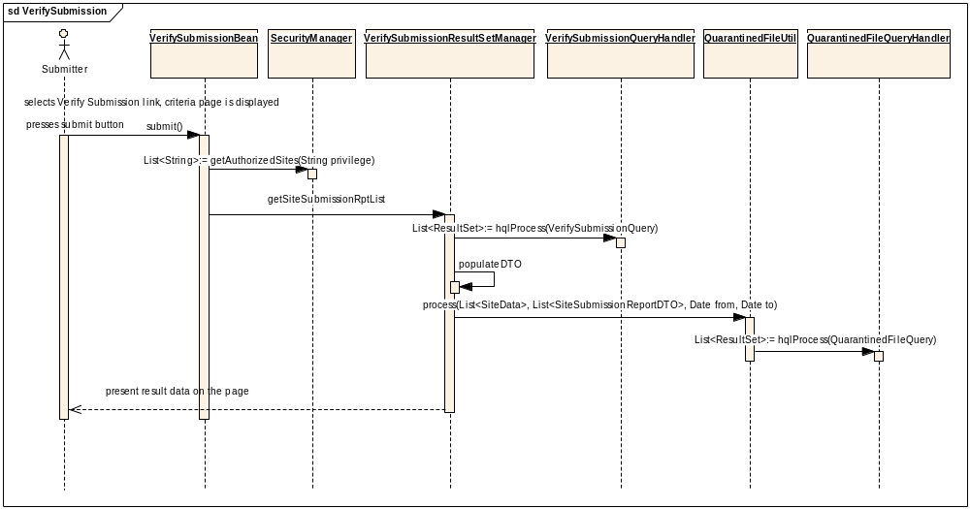

Components

USER INTERFACE
No changes.
A link to the Verify Submission page will be added to the left menu. This link will only be visible to those users who have VIEW_SUBMISSION_REPORT privilege.
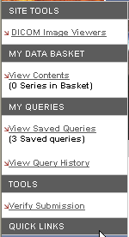

Search Page
No changes.
A new Verify Submission page will be created to include the criteria to search for Project-Site and Date range. The result of the search after the submitter presses the submit button will be presented on the bottom of the same page.
The Date component of the Tomahawk.jar will be used to show popup calendar.
Filter Site List on the Search section of the page based on security. The application uses the CSM to determine which protection elements representing sites that the user has VIEW_SUBMISSION_REPORT privilege for.
The page will appear as follows:
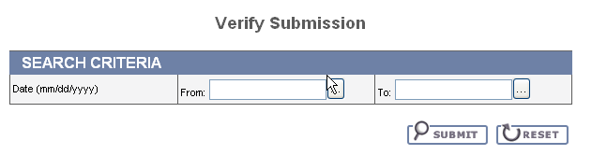

Search Results
When user presses the submit button, a textual message “Please wait. This may take a moment” is displayed to let user know that the search is in progress.
The Search Results will be presented at the bottom of the Verify Submission page after the submitter presses the submit button. The results will be grouped by Project-Site and include each date in the date range where files were submitted for Patient, Study, Series, Images and Annotation files. The number of files that were quarantined will also be presented for each Site.
A separate section of the results will present the number of the files that were quarantined but for which the site cannot be determined (for example, invalid DICOM header, no manifest in zip file, etc). It will appear as follows:

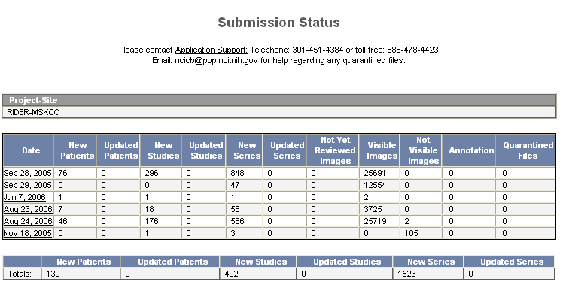

When a date link is clicked, the following row will display to show the UIDs for that date

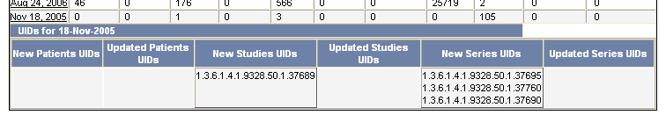

User interface Backing Beans

VerifySubmissionBean
A new backing bean (VerifySubmissionBean) will be created to manage the search process. When a user submits a query, it stores the submitted criteria and creates a VerifySubmissionQuery based on it.
New Methods | Type | Description
submit | String | Construct the criteria objects, call validateRange, add criteria for security and call query method to execute the query.
getDateFrom | Date | Get the date value from the From field
setDateFrom | void | Set the date value
getDateTo | Date | Get the date value from the To field
setDateTo | void | Set the date value
validateRange | Boolean | This method will validate the date fields. The validation rules are listed in the use case. The following error messages will be displayed:  - “To date must be after the From date.”  - “If a To date is included, a From date must be included.”  - “{0} is an invalid date”, where {0} indicates the field name.  - “{0} must not be in the future”, where {0} indicates the field name.
reset | void | Refresh the page, clear the form and remove the result section
getResults | List | Contains the results that will be displayed on the result page.

SiteSubmissionReportDTO
No changes.
SiteSubmissionReportDTO will be created to hold results for a site. The following new attribute will be added:
New Attribute | Type | Description
siteName | String | hold site value
submisionRptDate | List<SubmissionReportDateDTO> | Hold list of SubmissionReportDateDTO
project | String | Hold project name

SubmissionReportDateDTO

SubmissionReportDateDTO will be modified to hold data for a single day for a specific Project-Site.
New Attribute | Type | Description
submissionDate | Date | Hold submission date
numberOfImage | Integer | Hold number for images
numberOfAnnotation | Integer | Hold number of annotation files
numberOfNewPatients | Integer | Hold number of new patients
numberOfUpdatePatients | Integer | Hold number of update patients
numberOfNewStudies | Integer | Hold number of new studies
numberOfUpdatePatients | Integer | Hold number of update studies
numberOfNewSeries | Integer | Hold number of new series
numberOfUpdateSeries | Integer | Hold number of update series
numberOfVisibleImage | Integer | Hold number of visible images
numberOfQuarantinedFile | Integer | Hold number of quarantined files
newPatientsPkId | Set<Integer> | Hold new patient pk id
updatedPatientsPkId | Set<Integer> | Hold update patient pk id
newStudiesPkId | Set<Integer> | Hold new study pk id
updatedStudiesPkId | Set<Integer> | Hold update study pk id
newSeriesPkId | Set<Integer> | Hold new series pk id
updatedSeriesPkId | Set<Integer> | Hold update series pk id

New Methods | Type | Description
addPatients(Integer patientPkId, Boolean updateFlag) | void | Add the patientPkId based on the updateFlag. If updateFlag is true, then add patientPkId to updatedPatientsPkId set, otherwise, add to newPatientsPkId.
addStudies(Integer studyPkId, Boolean updateFlag) | void | Add the studyPkId based on the updateFlag. If updateFlag is true, then add studyPkId to updatedStudiesPkId set, otherwise, add to newStudiesPkId.
addSeries(Integer seriesPkId, Boolean updateFlag) | void | Add the seriesPkId based on the updateFlag. If updateFlag is true, then add seriesPkId to updatedSeriesPkId set, otherwise, add to newSeriesPkId.

BeanManager

An existing class needs to be modified to add VerifySubmissionBean

MIDDLE TIER

SiteCriteria
No changes.
A new criteria class extends TransientCriteria named SiteCriteria will be added. It will have the following attribute:
New Attribute | Type | Description
site | List<SiteData> | Set of Sites user wants to return as part of the results(SiteDate)

DateRangeCriteria
No changes.
A new criteria class extends TransientCriteria named DateRangeCriteria will be added. It will have the following methods:
New Attribute | Type | Description
fromDate | Date | hold date value user selects from search page
toDate | Date | Hold date value user selects from search page

VerifySubmissionQuery
No changes.
A new VerifySubmissionQuery will be created to hold the criteria.
New Attribute | Type | Description
siteCriteria | SiteCriteria | Contains site criteria for the search
dateCriteria | DateRangeCriteria | Contains date criteria for the search

QuarantinedFileQuery
No changes.
A new QurantinedFileQuery class will be created to hold the criteria. This class is created because for quarantined files of type xml and zip, the project and site information will be retrieved from database.
New Attribute | Type | Description
seriesAndStudyInstanceUid | Hashmap<String, String> | Contains hashmap of seriesInstanceUid and studyInstanceUid

QueryType
No changes.
This is an existing class. A new queryType named VERIFY_SUBMISSION_QUERY_TYPE will be created to handle VerifySubmissionQuery.
A new queryType named QUARANTINED_FILE_QUERY_TYPE will be created to handle QuarantinedFileQuery.

QueryFactory
No changes.
This is an existing class. This class will be modified to return VerifySubmissionQuery in case the QueryType is VERIFY_SUBMISSION_QUERY_TYPE and QuarantinedFileQuery in case the QueryType is QUARANTINED_FILE_QUERY_TYPE.

VerifySubmissionResultSet
No changes.
The VerifySubmissionResultSet class represents one row of data returned from the query executed by VerifySubmissionQueryHandler. It will contain the following data:
- Site Name
- Submission Date
- Number of Image
- Number of Annotation
- Number of Patients
- Number of Studies
- Number of Series
- Number of Visible Image
- Project

QuarantinedFileResultSet
No changes.
The QuarantinedFileResultSet class represents one row of data returned from the query executed by QuarantinedFileQueryHandler. It will contain the following data:
- Id
- SeriesInstance UID
- StudyInstance UID
- Site Name
- Project
- Submission Date

VerifySubmissionResultSetManager
This class is modified to get the date for each patient, study, series from VerifySubmissionUtil class to determine whether a patient, study or series is a new record or an updated record.
VerifySubmissionResultSetManager is responsible for the running a search based on a VerifySubmissionQuery and managing the results. This class will also handle the rolling up of the three queries (Section 6.5) to get counts for each Project-Site-Date and combines list of DTOs from queries and quarantine file utility.
The following methods will be created:
Method Name | Type | Description of Change
getSiteSubmissionReportList | List | For each VerifySubmissionResultSet returns, populate SiteSubmissionReportDTO with data. It also calls QuarantinedFilesUtil.process() method to get the number of quarantined files

VerifySubmissionQueryHandler
No changes.
A new VerifySubmissionQueryHandler will be created to process VerifySubmissionQuery. To build HQL for date ranges, use the DATE_FORMAT property in ncia.properties.
New Method Name | Description
hqlProcess | Convert the VerifySubmissionQuery into hql string and run the query (ida.query()). This will be done by executing 3 queries (3 views will be created. See database section)

QuarantinedFileQueryHandler
No changes
A new QuarantindeFileQueryHandler will be created to process quarantined files.
New Method Name | Description
hqlProcess | Convert the QuarantinedFileQuery into hql string and run the query (ida.query()). This will be done by executing the query in Section 6.5.4.4

UTILITIES

Utility class to handle quarantined files
No changes.

A new class QuarantinedFilesUtil.java will be created to calculate number of quarantined files for each Project-Site. This class will use the quarantined-files-directory to get all the quarantined files and loop through each one of them to determine its project-site and calculate the total count for each project-site. A file (DICOM, XML, or ZIP) will be added to unknown site quarantined files counter when the Project-Site cannot be determined.

New Method | Type | Description
Process(List<SiteData>, List<SiteSubmissiontReportDTO>, Date from, Date to) | void | Calculate the number of quarantined files

The quarantined-files-directory contains .qe files which contain the actually location of the quarantined files. The .qe file is opened and read in the actual location of the quarantined files. This location is used to open the actual file.

DICOM Files:

The following tags from the dicom header are retrieved to determine the project-site information.
00130010 106 Project Name
00130011 107 Trial Name
00130012 108 Site Name
00130013 109 Site Id

XML files:
The following series and study information are retrieved from the XML file. These values are used to lookup Project-Site information in the Database.
<SeriesInstanceUid>
<StudyInstanceUID>

Zip files:
The series and study information are retrieved from the manifest.xml file. These values are used to lookup Project-Site information in the Database.
<SeriesInstanceUid>
<StudyInstanceUID>

For XML files and Zip files, the QuarantinedFileQuery is used to hold criteria, QuarantinedFileUtil will be responsible for running the QuarantinedFileQueryHandler and managing the results.

Note: There is a bug in MIRC software that needs to be fixed for this enhancement. Currently dicom header (project name, trial name, site name, and site id) in dicom quarantined files were removed. A status check needs to perform before removing the header from dicom file.

The following sql is built to get Project and Site given series instance UID and study instance UID: Using OR for more than one set of series instance uid and study instance uid.
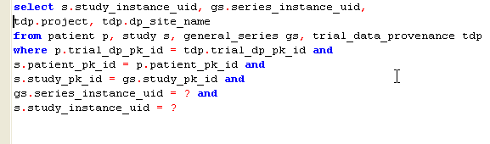

Utility class to get date information for patients, study, series

A new class, VerifySubmissionUtil is created to get the date for patients, study and series for a given project and site.
New Method | Type | Description
getPatientsDateInfo(VerifySubmissionQuery q) | List<Object> | Get the min and max submission date and patient_pk_id for each patient within a given project and site.
getStudiesDateInfo(VerifySubmissionQuery q ) | List<Object> | Get the min and max submission date and study_pk_id for each patient within a given project and site.
getSeriesDateInfo(VerifySubmissionQuery q) | List<Object> | Get the min and max submission date and series_pk_id for each patient within a given project and site.

MIRC DBExport Module

No changes.

When saving annotation data the database, the submissionDate for AnnotationImpl is set to the system date.

NCIAConfig Class
No changes.
A new entry will be added in ncia.properties file to specify the date format. NCIAConfig class will be modified to read in this entry, add method getDateFormat(String) that converts the string into a dateFormat and return that DateFormat.
The purpose of providing a date-format in the ncia.properties file is to allow users who use other type of database (mysql, db2, etc) a flexibility to providing the format for their database.
A new entry “quarantined-files-directory” will be added to ncia.properties file. NCIAConfig class will be modified to read in the value for quarantined-files-directory.

CSM Configuration
No changes.
TableProtectionElement class will be modified to add List of privileges that a user has.
New Attribute | Type | Description
privileges | List | Contains a set of privileges a user has such as READ, VIEW_SUBMISSION_REPORT, etc...

The following methods in AuthorizationManager class will be modified to pass in a privilege for certain methods
public List<String> getAuthorizedCollections(String privilege)
public void authorizeSitesAndSSGs(DICOMQuery query, String privilege)
public boolean authorizeCollections(DICOMQuery query, String privilege)
private List<String> findValuesFromAuthorizationData(String tableName, String columnName, String privilege)
Appropriate calls from search pages to these methods will be modified to pass in privilege as a String.
A new method public List<String> getAuthorizedSites(String privilege) will be created to get privileges for the user.

BACK END

Domain Classes

No changes.

Database Design

The following table and views are modified / added for this enhancement.

Tables

No changes.

Views

SUBMITTED_VISIBLE

DDL:

CREATE OR REPLACE VIEW SUBMITTED_VISIBLE AS(
SELECT tdp.project, tdp.dp_site_name, trunc(gi.submission_date, 'DDD') as submission_date, tdp.trial_dp_pk_id as trial_dp_pk_id,
gi.patient_pk_id as patient_pk_id,
gi.study_pk_id as study_pk_id,
gi.general_series_pk_id as series_pk_id,
count(gi.image_pk_id) as number_of_images
FROM trial_data_provenance tdp, general_image gi
WHERE gi.trial_dp_pk_id = tdp.trial_dp_pk_id AND
gi.visibility = 1
GROUP BY tdp.project, tdp.dp_site_name, trunc(gi.submission_date, 'DDD'),
tdp.trial_dp_pk_id, gi.patient_pk_id, gi.study_pk_id, gi.general_series_pk_id )

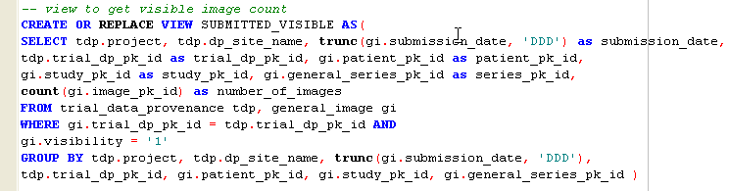

SUBMITTED_NON_VISIBLE
Column Name | Column Type | Class / Attribute Name
SERIES_PK_ID | NUMBER | SubmittedNonVisible.id
PROJECT | VARCHAR2 | SubmittedNonVisible.project
DP_SITE_NAME | VARCHAR2 | SubmittedNonVisible.siteName
SUBMISSION_DATE | DATE | SubmittedNonVisible.submissionDate
PATIENT_PK_ID | NUMBER | SubmittedNonVisible.patientId
STUDY_PK_ID | NUMBER | SubmittedNonVisible.studyId
TRIAL_DP_PK_ID | NUMBER | SubmittedNonVisible.trialDataProvenanceId
NUMBER_OF_IMAGES | VARCHAR | SubmittedNonVisible.numberOfImage

Modify this view to get all images that are not visible.

DDL:

CREATE OR REPLACE VIEW SUBMITTED_NON_VISIBLE AS(
SELECT tdp.project, tdp.dp_site_name, trunc(gi.submission_date, 'DDD') as submission_date, tdp.trial_dp_pk_id as trial_dp_pk_id,
gi.patient_pk_id as patient_pk_id,
gi.study_pk_id as study_pk_id,
gi.general_series_pk_id as series_pk_id,
count(gi.image_pk_id) as number_of_images
FROM trial_data_provenance tdp, general_image gi
WHERE gi.trial_dp_pk_id = tdp.trial_dp_pk_id AND
gi.visibility <> 1
GROUP BY tdp.project, tdp.dp_site_name, trunc(gi.submission_date, 'DDD'),
tdp.trial_dp_pk_id, gi.patient_pk_id, gi.study_pk_id, gi.general_series_pk_id )

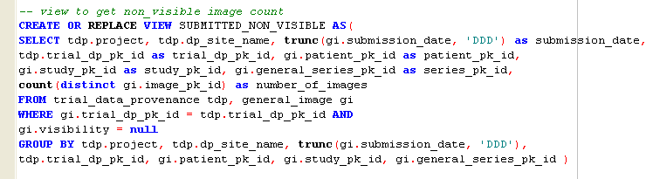

SUBMITTED_ANNOTATION

No changes.

DDL:

CREATE OR REPLACE VIEW SUBMITTED_ANNOTATION AS(
SELECT tdp.project, tdp.dp_site_name, trunc(a.submission_date, 'DDD') as submission_date,
tdp.trial_dp_pk_id as trial_dp_pk_id, p.patient_pk_id as patient_pk_id,
s.study_pk_id as study_pk_id, gs.general_series_pk_id as series_pk_id,
count(distinct a.annotations_pk_id) as number_of_annotation
FROM trial_data_provenance tdp, annotation a, general_series gs, study s, patient p
WHERE a.general_series_pk_id = gs.general_series_pk_id AND
tdp.trial_dp_pk_id = p.trial_dp_pk_id AND gs.study_pk_id = s.study_pk_id AND s.patient_pk_id = p.patient_pk_id
GROUP BY tdp.project, tdp.dp_site_name , trunc(a.submission_date, 'DDD'),
tdp.trial_dp_pk_id, p.patient_pk_id, s.study_pk_id, gs.general_series_pk_id )

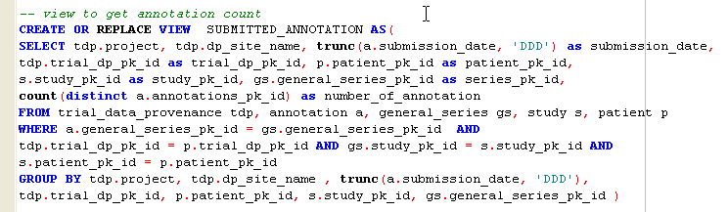

QUARANTINE
Column Name | Column Type | Class / Attribute Name
GS_SERIES_PK_ID | NUMBER | Quarantined.id
SERIES_INSTANCE_UID | VARCHAR2 | Quarantined.seriesInstanceUid
STUDY_INSTANCE_UID | VARCHAR2 | Quarantined.studyInstanceUid
DP_SITE_NAME | VARCHAR2 | Quarantined.siteName
PROJECT | VARCHAR2 | Quarantined.project

DDL:

CREATE OR REPLACE VIEW QUARANTINE AS (

SELECT gs.general_series_pk_id as gs_series_pk_id, gs.series_instance_uid, s.study_instance_uid, tdp.project, tdp.dp_site_name

FROM patient p, study s, general_series gs, trial_data_provenance tdp

WHERE p.trial_dp_pk_id = tdp.trial_dp_pk_id AND

s.patient_pk_id = p.patient_pk_id AND

s.study_pk_id = gs.study_pk_id )

